Laboratory Module: Cache Access Methods
Direct-Mapped • Fully Associative • Set-Associative
Course: Computer Architecture / Organization
Dave Jhared G. Paduada
BSCPE IV - GF

1) Introductory Statement
Modern processors rely on caches to hide main‑memory latency. This lab explores how memory addresses map to cache lines under three access methods—Direct‑Mapped (DM), Fully Associative (FA), and Set‑Associative (SA)—and how mapping, replacement, and write policies affect hits and misses. You will compute bit fields (tag/index/offset), simulate hit/miss timelines on short traces with LRU, analyze miss types (compulsory/capacity/conflict), and verify the VIPT (Virtually Indexed, Physically Tagged) page‑offset rule.

2) Learning Objectives
- Partition an address into Tag / (Set) Index / Block Offset across DM/FA/SA designs.
- Map addresses to lines/sets; determine hit/miss sequences and evictions under LRU.
- Distinguish compulsory, capacity, and conflict misses; relate to associativity.
- Compute storage overhead (tag store + metadata) for various designs.

3) Prerequisites
- Binary/hex conversion, powers of two, and bitwise shifting/masking.
- Understanding of byte‑addressed vs word‑addressed memory.
- Basic knowledge of LRU/FIFO/Random replacement and write‑through vs write‑back.

4) Materials & Tools
- Calculator (or Python/Excel/Google Sheets).
- This handout with data tables.
- Optional: simple trace simulator (spreadsheet or short script)

5) Background & Theory

5.1 Core Definitions
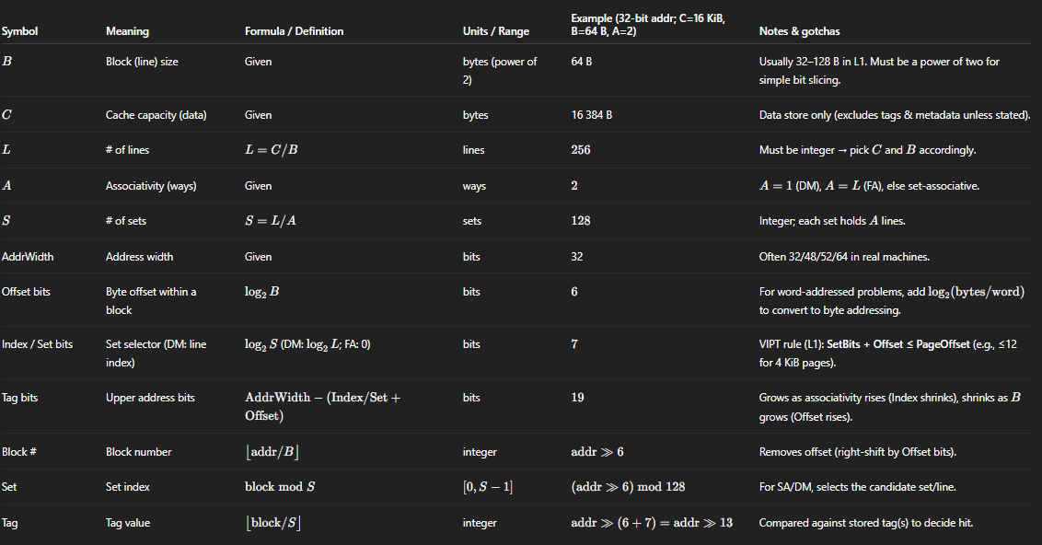
Miss taxonomy: Compulsory (first reference), Capacity (working set > cache), Conflict (mapping collisions within set).

Callout Box: Tag, Index, and Offset — Quick Guide
How a byte address is split in a cache lookup
[ Tag | Index / Set | Offset ]
(high bits) (middle) (low bits)

Intuition (a quick analogy)
- Offset = apartment room number inside a specific flat (the block).
- Index/Set = which building (set) to go to on the street.
- Tag = the neighborhood label so you know whether the building you’re at actually contains the address you want.

What they mean:
• Offset: Selects the byte position inside a cache block (line).
• Index / Set: Selects which set (DM: the exact line) to probe.
• Tag: Identifies which memory block is currently stored in that set/line.

Field | Selects | # bits | Formula (byte-addressed) | Hardware use
Offset | Byte inside block | log2(B) | offset = addr & (B-1) | Pick the exact byte/word from the fetched line
Index / Set | Set (DM: line) | log2(S) (DM: log2(L); FA: 0) | set = (addr >> log2(B)) & (S-1) | Choose which set to read; compare only here
Tag | Which block is here | AddrWidth - (Index/Set + Offset) | tag = addr >> (log2(B) + log2(S)) | Compare against stored tag(s) for hit/miss

Numeric mini-example (Direct-Mapped)
• Assume 32-bit addresses, C=8 KiB, B=32 B → L=256 lines.
• Bits: Offset=log2(32)=5; Index=log2(256)=8; Tag=32-(5+8)=19.
• Address format: [ Tag19 | Index8 | Offset5 ].
• Let X = 0x00401034.
• offset = X & 0x1F = 0x14 (20)
• index = (X >> 5) & 0xFF = 0x81 (129)
• tag = X >> 13 = 0x200 (512)
• On access, line=index=129 is probed; tag must match 0x200 (and valid=1) for a hit.

Common pitfalls
• Always compute Offset in BYTES (convert word-addressed problems to bytes first).
• Sizes should be powers of two for simple shift/mask formulas.
• DM collisions: addresses separated by 2^(Index+Offset) bytes map to the same line (ping-pong conflicts).
• VIPT L1 rule: SetBits + Offset ≤ PageOffset (e.g., ≤12 for 4 KiB pages).

5.2 Bit‑Field Diagrams

32‑bit configurations used throughout the comprehensive examples:
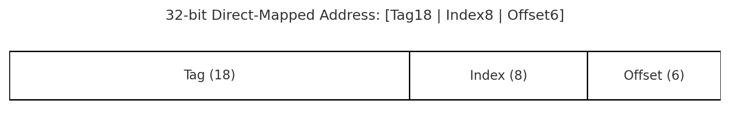
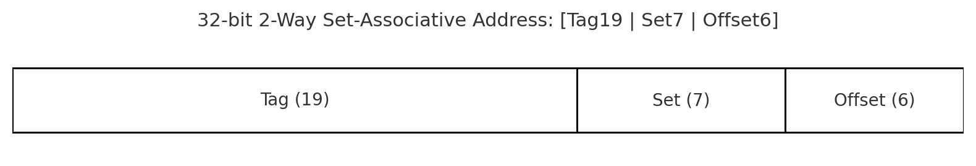
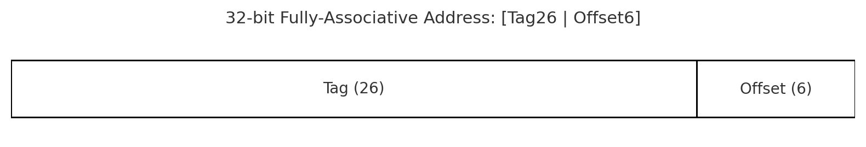
Toy 16‑bit examples (for board work / quick checks):
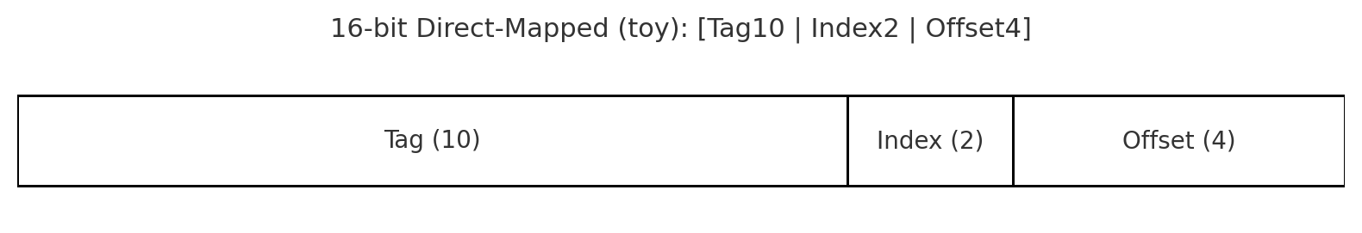
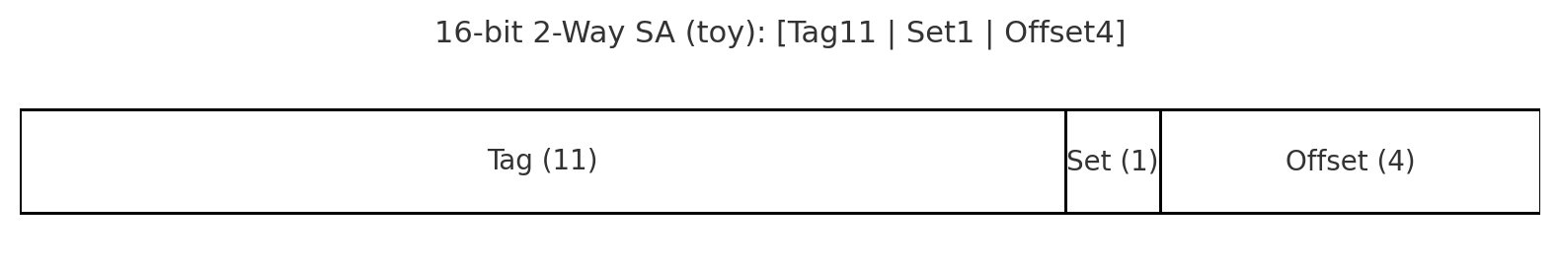

5.3 Direct-Mapped (DM)
Mapping & fields:
- line $=$block $mod L$ where block $=⌊\text{addr}/B⌋$.
- Address = [ Tag | Index | Offset ]
  - Offset $={log⁡}_{2}B$
  - Index $={log⁡}_{2}L$
  - Tag $=\text{AddrWidth}-(\text{Index}+\text{Offset})$
Access path (hardware):
- Decode Index → read one line’s tag & data.
- One tag comparator.
- If tag matches + valid → hit; else miss and the same line is the victim (no replacement policy needed).
Where it bites
- Conflict misses dominate: any two hot blocks that map to the same line ping-pong.
- At fixed $C$, increasing $B$ reduces the number of lines $L$→ Index bits shrink → more conflicts.
Tiny mini-example (numbers)
Given:
Address width | 32 bits
Cache capacity, C | 8 KiB = 8 × 1024 = 8192 B
Block (line) size, B | 32 B
Mapping | Direct‑Mapped (DM)

Derive Core Parameters:
a) Number of lines: L = C / B = 8192 / 32 = 256 lines.
b) Bit fields for Direct‑Mapped:
Field | Formula | Value
Offset bits | log2(B) | log2(32) = 5
Index bits | log2(L) | log2(256) = 8
Tag bits | AddrWidth − (Index + Offset) | 32 − (8 + 5) = 19
Address format | — | [ Tag19 | Index8 | Offset5 ]
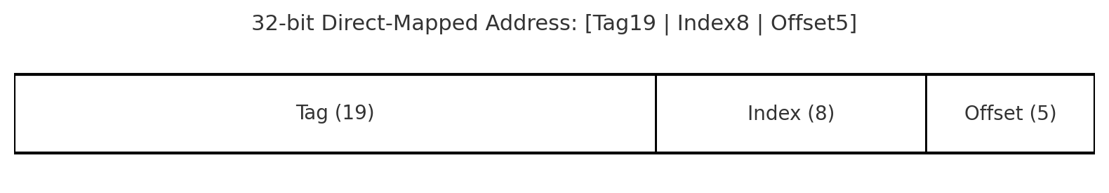
Same‑Line Stride (Why 0x2000?)
In a direct‑mapped cache, two addresses that differ by 2^(Index+Offset) bytes have the same index (and same offset). Only the tag changes. Therefore they map to the same cache line and will collide (ping‑pong) on alternating accesses.
Index bits | Offset bits | Same‑line stride (bytes)
8 | 5 | 2^(8+5) = 2^13 = 8192 = 0x2000

Concrete Proof with an Actual Address:
Choose base address X and add the same‑line stride:
Base address, X | 0x00401034
Stride | 0x2000 (8192)
Second address, X' = X + 0x2000 | 0x00403034

Masks & shifts (DM, L=256, B=32):
Offset mask = B − 1 = 0x1F; Index mask = L − 1 = 0xFF
Offset bits = 5 → shift >> 5; Tag shift = 5 + 8 = 13 → shift >> 13
Compute fields:
Address | Offset (5b) | Index (8b) | Tag (19b) | Comment
X = 0x00401034 | X & 0x1F = 0x14 (20) | (X >> 5) & 0xFF = 0x81 (129) | X >> 13 = 0x200 (512) | —
X' = 0x00403034 | X' & 0x1F = 0x14 (20) | (X' >> 5) & 0xFF = 0x81 (129) | X' >> 13 = 0x201 (513) | Tag increased by 1
Result: Same index (129) → same DM line; different tags → alternate accesses will evict each other (conflict ping‑pong).

5) Generalizations (Useful to Remember)
Same‑line stride (DM) | 2^(IndexBits + OffsetBits) bytes

5.4 Fully Associative (FA)
Mapping & fields
- Any block → any line.
- Address = [ Tag | Offset ] (no index).
  - Tag $=\text{AddrWidth}-\text{Offset}$.
Access path (hardware):
- Parallel compare of the incoming Tag against all valid lines’ tags (CAM-like).
- On miss with no free line, choose a victim via replacement policy.
Why it’s great
- Minimizes conflict misses (placement is flexible).
- Perfect for very small structures where full parallel compare is affordable: TLBs, victim caches, tiny L0 buffers.
Where it hurts
- Parallel tag compares across many lines are area/energy expensive; hit time can grow with size.
- True LRU across many lines is metadata-heavy; large FA data caches are rare.
Replacement policies (typical for FA)
- LRU for very small FA (e.g., 4–32 entries).
- Random/NRU for simplicity at moderate sizes.
- Modern predictors (D(R)RIP, bimodal insertion) appear in LLCs/SA caches more often than large FA.
Write behavior
- Same as others, but fewer conflict-driven write-backs than DM since hot blocks can co-reside.
Tiny mini-example (numbers)
Given:
Address width | 32 bits
Cache capacity, C | 8 KiB = 8 × 1024 = 8192 bytes
Block (line) size, B | 32 bytes
Mapping | Fully Associative (FA) — no set/index; any block can occupy any line

Derive Core Cache Parameters
a) Number of lines: L = C / B = 8192 / 32 = 256 lines.
b) Bit fields for FA (no index/set):
Field | Formula | Value
Offset bits | log2(B) | log2(32) = 5
Index/Set bits | FA → 0 | 0
Tag bits | AddrWidth − (Index/Set + Offset) | 32 − (0 + 5) = 27
Address format | — | [ Tag27 | Offset5 ]

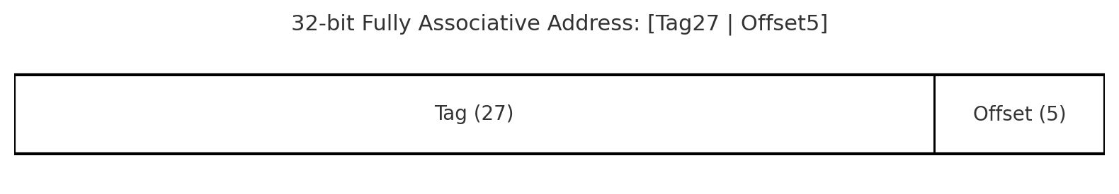
Intuition: in FA, the tag is simply the block number (`addr >> 5`), because there’s no set/index.
“300 Unique Blocks” Stream — Exact Miss Counts
We access 300 distinct blocks (no repeats), starting from a cold cache.
• At a cold start, the first reference to each block is a miss.
• The cache has 256 lines. After the first 256 distinct blocks, the cache is full.
• The remaining 44 distinct blocks (257…300) are also misses, each evicting an older line (e.g., by LRU).
Total references | 300
Total misses | 300
Compulsory misses | min(300, 256) = 256
Capacity misses | 300 − 256 = 44 (Conflict misses = 0 for FA)

Concrete Numeric Walk‑Through (first/last steps)
Define A_i = Base + (i−1)×B with B=32. Example Base = 0x00400000 (aligned).
Then tag_i = A_i >> 5 = (Base >> 5) + (i−1); offset = 0 for the first byte.
Ref # | Address A_i | Tag (FA) = A_i >> 5 | Classification
1 | Base + 0×32 | Base>>5 + 0 | Miss (compulsory)
2 | Base + 1×32 | Base>>5 + 1 | Miss (compulsory)
3 | Base + 2×32 | Base>>5 + 2 | Miss (compulsory)
4 | Base + 3×32 | Base>>5 + 3 | Miss (compulsory)
5 | Base + 4×32 | Base>>5 + 4 | Miss (compulsory)
… | … | … | …
256 | Base + 255×32 | Base>>5 + 255 | Miss (compulsory; cache becomes full)
257 | Base + 256×32 | Base>>5 + 256 | Miss (capacity; evict LRU #1)
… | … | … | …
300 | Base + 299×32 | Base>>5 + 299 | Miss (capacity; evict current LRU)

Typical use
- TLB (FA or high-assoc), victim cache (4–16 entries, FA), sometimes tiny instruction buffers.

5.5 Set-Associative (SA)
Mapping & fields
- Middle ground: $S$ sets × $A$ ways per set.
- Address = [ Tag | SetIndex | Offset ]
  - SetIndex $={log⁡}_{2}S$, A = associativity (ways).
- Mapping: set $=(\text{block}) mod S$; placement within the set is flexible (choose one of $A$ways).
Access path (hardware):
- Read all $A$tags (and often all $A$data words/lines in parallel), compare tags, select hit way via mux.
- If miss and set full, pick victim via replacement policy within the set.
Why it’s the default
- Dramatically fewer conflict misses than DM, but with far fewer comparators than FA.
- L1D is often 2–8-way; L2/L3 typically 8–16-way.
Latency/energy tricks
- Parallel vs serial lookup:
  - Parallel (tags+data together) = lower hit latency, higher power.
  - Serial (tags first, then data) = saves power, adds a bubble if not carefully pipelined.
- Way prediction: predict likely way → speculatively read one way (saves energy/latency on correct predictions).
- Banking/sub-banking: reduce conflicts and support multiple accesses (I/D split, multi-port illusion).
Replacement policies (within a set)
- True LRU up to ~4-way; beyond that, Tree-PLRU $(A-1)$bits/set or NRU/Random are common.
- Advanced: DIP/DRRIP family (useful in LLCs) to bias insertion for thrash-resistance.
Writes
- Write-back + write-allocate is common in data caches; metadata per line: Valid/Dirty (+ ECC/parity).
- SA reduces conflict-induced dirty evictions versus DM.
Tiny mini-example (numbers)
Given
Address width | 32 bits
Cache capacity, C | 16 KiB = 16,384 bytes
Block (line) size, B | 64 bytes
Associativity, A | 2 (2-way Set-Associative)

Derive Core Cache Parameters
a) Number of lines: L = C / B = 16,384 / 64 = 256 lines.
b) Number of sets: S = L / A = 256 / 2 = 128 sets.
c) Bit fields for FA (no index/set):
Field | Formula | Value
Offset bits | log2(B) | log2(64) = 6
Index/Set bits | log2(S) | log2(128) = 7
Tag bits | AddrWidth − (Index/Set + Offset) | 32 − (7 + 6) = 19
Address format | — | [ Tag19 | SetIndex7 | Offset6 ]

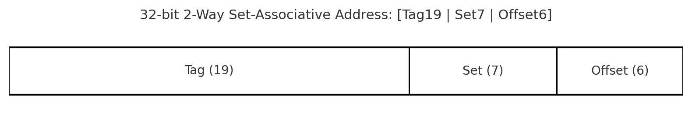
Same-Set Stride — Why 2^(Offset+SetIndex) = 2^(6+7) = 0x2000
SetIndex occupies bits [6..12] (LSB=bit0) and Offset occupies bits [0..5]. Adding 2^(6+7)=2^13=0x2000 flips bit 13 while keeping bits 0..12 unchanged, so Offset and SetIndex remain the same; only Tag changes.
Offset bits | SetIndex bits | Same-set stride (bytes)
6 | 7 | 2^(6+7) = 2^13 = 8192 = 0x2000

Concrete Verification with Actual Addresses
Choose a 64-byte aligned base: X = 0x00401000.
Compute (byte-addressed):
offset = addr & (B-1) with B=64 → B-1 = 0x3F
set = (addr >> 6) & (S-1) with S=128 → S-1 = 0x7F
tag = addr >> (6 + 7) = addr >> 13
Address | Offset (6b) | SetIndex (7b) | Tag (19b) | Observation
X = 0x00401000 | 0 | (0x00401000 >> 6) & 0x7F = 64 | 0x00401000 >> 13 = 512 | Base
X + 0x2000 = 0x00403000 | 0 | (0x00403000 >> 6) & 0x7F = 64 | 0x00403000 >> 13 = 513 | same set, tag+1
X + 0x4000 = 0x00405000 | 0 | (0x00405000 >> 6) & 0x7F = 64 | 0x00405000 >> 13 = 514 | same set, tag+2
Result: All three addresses map to Set 64; tags {512, 513, 514}. Three contenders for a 2-way set.

2-Way Set Behavior with LRU (Thrash Demo)
Sequence: < X, X+0x2000, X, X+0x4000, X+0x2000, X > (cache cold; set=64).
Step | Access | Tag | Hit/Miss | Set 64 (Before) | Action | Set 64 (After, MRU→LRU)
1 | X | 512 | Miss | [ –, – ] | Fill empty way | [512, –]
2 | X+0x2000 | 513 | Miss | [512, –] | Fill other empty way | [513, 512]
3 | X | 512 | Hit | [513, 512] | Touch 512 → MRU | [512, 513]
4 | X+0x4000 | 514 | Miss | [512, 513] | Evict LRU=513, insert 514 | [514, 512]
5 | X+0x2000 | 513 | Miss | [514, 512] | Evict LRU=512, insert 513 | [513, 514]
6 | X | 512 | Miss | [513, 514] | Evict LRU=514, insert 512 | [512, 513]
Observation: With three contenders {512, 513, 514} in a 2-way set, the third arrival always forces an eviction; the set thrashes whenever contenders per set > A.

6) Problems
Shared base parameters: C=16 KiB, B=64 B ⇒ L=256 lines.
DM: A=1 ⇒ S= 256; Offset=6, Index 8, Tag = 18.
2‑Way SA: A=2 ⇒ S= 128; Offset = 6, SetIndex = 7, Tag = 19.
FA: A=256 ⇒ S=1; Offset= 6, Tag = 26.
Conflict stride for DM = 2^(Index+Offset) = 2^(8 + 6) = 16384.

6.1 Address Set and Trace
Addresses (hex): A1=0x004030C0; A2=A1+0x4000=0x004070C0; A3=A1+0x8000=0x0040B0C0; A4=A1+0xC000=0x0040F0C0; and in‑block neighbors A1+0x18, A2+0x20, A3+0x38.
12‑access trace T: <A1, A1+0x18, A2, A2+0x20, A1, A3, A3+0x38, A1, A2, A3, A4, A1>.

6.2 Direct‑Mapped (DM) Bit‑Accurate Walk‑Through
Address format: [Tag18 | Index8 | Offset6]. Example A1 (0x004030C0): Tag=0x100, Index=0xC3, Offset=0.
Step | Access | Index | Tag | Hit/Miss | Eviction/Action
1 | A1 | C3 | 100 | Miss | Load line(C3.tag=100)
2 | A1+18 | C3 | 100 | Hit | Same block
3 | A2 | C3 | 101 | Miss | Evict 100 → Load 101
4 | A2+20 | C3 | 101 | Hit | —
5 | A1 | C3 | 100 | Miss | Evict 101 → Load 100
6 | A3 | C3 | 102 | Miss | Evict 100 → Load 102
7 | A3+38 | C3 | 102 | Hit | —
8 | A1 | C3 | 100 | Miss | Evict 102 → Load 100
9 | A2 | C3 | 101 | Miss | Evict 100 → Load 101
10 | A3 | C3 | 102 | Miss | Evict 101 → Load 102
11 | A4 | C3 | 103 | Miss | Evict 102 → Load 103
12 | A1 | C3 | 100 | Miss | Evict 103 → Load 100

6.3 2‑Way Set‑Associative (SA) with LRU
Address format: [Tag19 | Set7 | Offset6]. All A1–A4 map to Set=0x43 but can occupy two ways.
Step | Access | Set | Tag | Hit/Miss | Before (ways) | After (ways) / Eviction
1 | A1 | 43 | 513 | Miss | [–, –] | [513, –]
2 | A1+18 | 43 | 513 | Hit | [513, -] | [513, -]
3 | A2 | 43 | 515 | Miss | [513, -] | [513, 515]
4 | A2+20 | 43 | 515 | Hit | [513, 515] | [513, 515]
5 | A1 | 43 | 513 | Hit | [513, 515] | [513, 515]
6 | A3 | 43 | 517 | Hit | [513, 515] | Evict 515-> [513, 517]
7 | A3+38 | 43 | 517 | Hit | [513, 517] | [513, 517]
8 | A1 | 43 | 513 | Hit | [513, 517] | [513, 517]
9 | A2 | 43 | 515 | Miss | [513, 517] | Evict 517-> [513, 515]
10 | A3 | 43 | 517 | Miss | [513, 515] | Evict 513-> [517, 515]
11 | A4 | 43 | 519 | Miss | [517, 515] | Evict 515->[517,519]
12 | A1 | 43 | 513 | Miss | [517, 519] | Evict 517-> [519, 513]

6.4 Fully Associative (FA) with LRU
Address format: [Tag26 | Offset6]. 4 unique blocks; cache has 256 lines → all co‑exist after first touches.
Step | Access | Hit/Miss | Notes
1 | A1 | Miss | First touch of A1 block
2 | A1+18 | Hit | Hits A1 block
3 | A2 | Miss | First touch of a2 block
4 | A2+20 | Hit | Hits A2 block
5 | A1 | Hit | A1 is already resident
6 | A3 | Miss | First touch of A3 block
7 | A3+38 | Hit | Hits A3 block
8 | A1 | Hit | A1 is still resident
9 | A2 | Hit | A2 is still resident
10 | A3 | Hit | A3 is still resident
11 | A4 | Miss | First touch of A4 block. Cache now holds 4 lines (A1, A2, A3, A4)
12 | A1 | Hit | A1 is still resident

7) More Review & Exercise Problems
Q1 — Bit Fields (Direct-Mapped)
Given: C = 32 KiB, B = 64 B, Mapping = Direct-Mapped (A=1).
Steps:
1) L = C / B = 32,768 / 64 = 512 Lines
2) Offset bits = log₂ (64) = 6 bits
3) Index bits = S = 512 -> log₂ (512) = 9 bits
4) Tag bits = 32 – (9 + 6) = 17 bits
Tag (bits) | Index (bits) | Offset (bits)
17 | 9 | 6

Q2 — Bit Fields (2-Way Set-Associative)
Given: C = 16 KiB, B = 32 B, A = 2.
Steps:
1) L = C / B = 16,384 / 32 = 512 Lines
2) S = L / A = 512 / 2 = 256 sets
3) Offset bits = log₂ (32) = 5 bits
4) SetIndex bits = log₂ (256) = 8 bits
5) Tag bits =
Tag (bits) | Index (bits) | Offset (bits)
19 | 8 | 5

Q3 — Mapping Fields (Use Q2 parameters)
Given: Address = 0x12345678; C = 16 KiB, B = 32 B, A = 2 → Offset=5, SetIndex=8, Tag=19.
Compute:
block = addr >> 5
set = (addr >> 5) & 0xFF (since S = 256)
tag = addr >> (5 + 8) = addr >> 13
Addr | 0x12345678
block = addr >> 5 | 0x91A2B3
set = (addr>>5) & 0xFF | 0xB3
tag = addr >> 13 | 0x91A2

Q4 — DM Conflict Pair (Craft Two Colliding Addresses)
Use Q1 parameters (Offset=6, Index=9). In a DM cache, addresses that differ by 2^(Index+Offset) bytes collide (same line).
2^(Index+Offset) = 2^(9+6) = 2^15 = 32,768 = 0x8000.
Example: choose X = 0x00401000 ⇒ X' = X + 0x8000 = 0x00409000.
Both X and X' have the same index & offset, but different tag → they collide in DM.

Calculation: Index = 9 bits, Offset = bits
Stride = 2^(9 + 6) = 2^15 = 32, 768 = 0x8000
X = 0x00401000 ⇒ X' = X + 0x8000 = 0x00409000.

Q5 — DM Trace Miss Count
DM, C = 8 KiB, B = 32 B (Offset=5, Index=8). Trace: X, X+0x2000, X, X+0x4000, X+0x2000, X. Cold start.
Same-line stride for DM = 2^(Index+Offset) = 2^(8+5) = 2^13 = 0x2000.
Any multiple of 0x2000 leaves Index and Offset unchanged → X, X+0x2000, and X+0x4000 all map to the same line.
Step | Address | Same Line as X? | Hit/Miss | Reason
1 | X | — | Miss | Cold start
2 | X+0x2000 | Yes | Miss | Conflict (Evicts X)
3 | X | Yes | Miss | Conflict (Evicts X+0x2000)
4 | X+0x4000 | Yes | Miss | Conflict (Evicts X)
5 | X+0x2000 | Yes | Miss | Conflict (Evicts X+0x4000)
6 | X | Yes | Miss | Conflict (Evicts X + 0x2000)

Q6 — 2-Way SA Trace (LRU)
Same addresses as Q5 but 2-way set-associative, LRU. C = 8 KiB, B = 32 B → L=256; A=2 ⇒ S=128 (SetIndexBits=7; Offset=5).
Same-set stride = 2^(SetIndex+Offset) = 2^(7+5) = 2^12 = 0x1000.
Since 0x2000 = 2×0x1000 and 0x4000 = 4×0x1000, all three addresses X, X+0x2000, X+0x4000 map to the **same set**.
With 3 contenders in a 2-way set, the set thrashes under LRU (only the 3rd access to a different tag evicts one of the two resident ways).
Step | Access | Tag (relative) | Hit/Miss | Set State (Before) | Set State (After)
1 | X | T0 | Miss | [ -, - ] | [T0, -]
2 | X+0x2000 | T1 | Miss | [T0, -] | [T1, T0]
3 | X | T0 | Hit | [T1, T0] | [T0, T1]
4 | X+0x4000 | T2 | Miss | [T0, T1] | [T2, T0]
5 | X+0x2000 | T1 | Miss | [T2, T0] | [T1, T2]
6 | X | T0 | Miss | [T1, T2] | [T0, T1]

